**Pie Chart**

## Simple Pie Chart

We can choose one dimension and one measure to create a simple pie chart. For our example, let's take the dimension named region with the measure named profit. Drop the Region dimension in the colors and and label marks. Drop the Profit measure into the size mark. Choose the chart type as Pie. The below chart appears which shows the 4 regions in different colours.

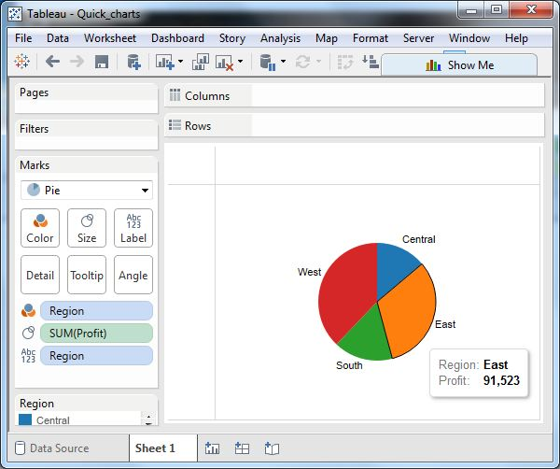

## Drill Down Pie Chart

We can choose a dimension with hierarchy and as we go deeper into the hierarchy the chart changes reflecting the level of the dimension chosen. In the below example, we take the dimension subcategory which has two more levels - Manufacturer and Product Name. We take the measure profit and drop it to the Labels mark. The pie chart below appears which shows the values for each slice.

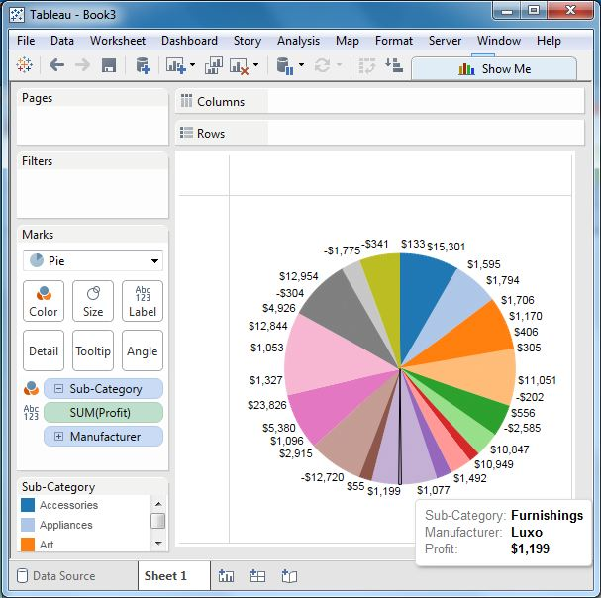

Going one more level into the hierarchy, we get the manufacturer as the label and the above pie chart changes to the one shown below.

